In 1992, the SQL 92 database convention created the specifications for an upgrade to cross tabulations.

Cross tabs had been used “forever” in databases to allow users to get more of a handle on information. Take the example of a credit card company with cards throughout the country. It might be important to know credit card balances for each state. For example:
AL | 2000000
Ca | 350000
MA | 2500000
NY | 3000000
PA | 900000
What if we wanted to know the breakown of payments and who was late. Cross tab could give you the following
State | <30 | <60 | <90 | >90
Al | 1000000 | 500000 | 250000 | 250000
Ca | 350000
Ma | 2000000 | 500000
NY | 1000000 | 500000 | 1000000 | 500000
PA | 800000 | 100000
Using Cross Tab, the end user as the decision maker can get more insight into the problem.

The upgrade to Cross tab is Pivot Table. Pivot tables give the user quite a bit of info – most of which we cannot go into for lack of time – at minimum preparation.

Please remember this lack of info was the problem with subtotals. There was a need to sort and in the end only one statistic was allowed. Pivot tables do not need this preparation and multiple statistics are allowed (although this can be confusing)

The only prep that is needed is that the table must have unique column headers because the Pivot table needs a visual description. Below is the layout of a pivot table
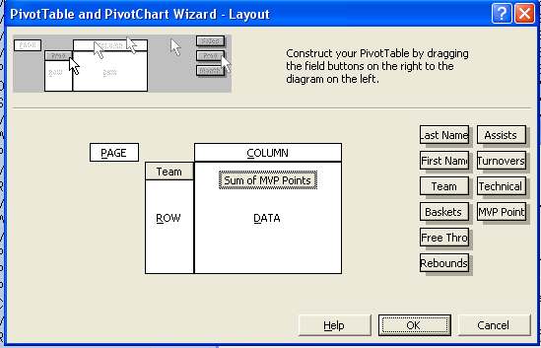
Notice that Pivot tables are broken into 4 parts.
- Page, which we will not discuss.
- Row and Column which act as the basic of a cross tab.
- Data, which accepts all types of numerical possibilities

Data components (statistics) can be modified by double clicking. There are multiple possibilities but we’ll stick with sum and average. Below is an example of choosing an average. Notice also thre Numbers command button. Clicking this will allow formatting
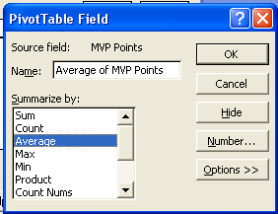

Processing our example gives the pivot table
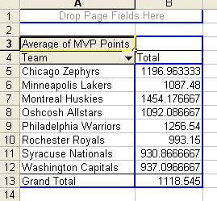

Pivot tables are not only visual but flexible also. Row and column headers can be grabbed and moved on this sheet if necessary.

Sorts on this data (since the system already knows where the table is) are easier. Move your cursor on the column that needs to be sorted and click data/sort. Below is the result
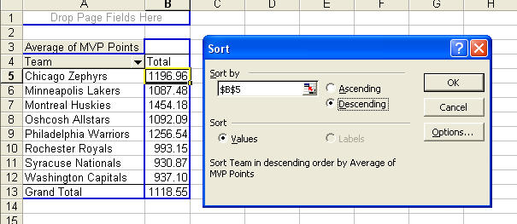

The user is set to modify the order of the data very quickly.

Charts can be done very quickly also. Clicking the right button on the table give a pivot chart option. Blow is the result of this action.

