1

30 pts.The Famous Name Deli has the following part time workers (perhaps you can understand the name of this Deli by this list). You are asked to calculated their approximate take home pay (gross earnings after a set of taxes and expenses) . Do this as we did the Big W auto dealership

|  |  |  |  |
| --- | --- | --- | --- |
| Last Name | First name | Hours worked | Salary/hr |
| Wayne | Bruce | 200 | 25 |
| Lane | Lois | 600 | 20 |
| Kyle | Salina | 900 | 30 |
| Kent | Clark | 1050 | 75 |
| Potter | Harry | 600 | 15 |
| Leia | Princess | 1000 | 35 |
| Jones | Indiana | 700 | 20 |
| Calahan | Harry | 300 | 25 |
| Benes | Elaine | 1025 | 45 |

Included in this table is the number of hours worked and the rate per hour. Yearly totals therefore are Hours worked multiplied by Salary/hr. Create a new workbook to answer the following problems.

1. In a new workbook in excel, enter this information
2. In a new column, calculate total earnings for the year. Note: This is gross earnings and is defined as hours worked multiplied by rate per hour as indicated above. In the first case this would be 200*25 = 5000.
3. One tax that is paid is Social Security (FICA on our paycheck). This tax is 7.65% of gross earnings Create a new column indicating the Social Security taxes paid by each employee.
4. Another tax is State tax, taxed at a 3.1% rate on gross earnings. Create another column calculating State tax.
5. The famous name deli has a Section 125 plan. This allows an individual to apply several payments using before tax funds. The Famous Name Deli plan allows for 2000 or 15 percent of total earnings (what you calculated in B) whichever is less. We have a function designated as Min() in excel that will provide the minimum of 2 numbers when separated by comma. Use min to determine the amount of Section 125 funding for each employee. (in the first case 15% of total salary is 750. Min(750,2000) would yield 750)
6. Calculate the net take home salary. This is what you calculated in B minus the values calculated in C,D and E
7. Use conditional formatting to highlight those employees whose take home salary is greater than $30000
8. Format your table appropriately and format the numbers so they look consistent.
9. Sort high to low based on your calculation of B
10. Use a Bar chart to visually show the results of B. Now, we could have used another chart as mentioned in class. Would a Pie chart have given more information?______________________

______________________________________________________________________________



2

30 points. Open the file **bond,james bond.xlsx** (sorry, I couldn’t resist). This lists the James Bond movies in chronological order of release. You can see the star of the movie (this would be the actor playing James Bond,), The **US box office** which we will not be using, the **worldwide box office**, the **production cost** and the **inflation factor to 2008**. We are going to calculate the **total profit** (**world wide box office** – **production cost**) in 2008 dollars and run a pivot table determining who was the most popular actor in terms of financial gains.

1. To start this, create a new column, **net profit**, subtracting **production cost** from **world wide box office.**
2. We need to set this to 2008 dollars. Multiply **net profit** by **inflation factor to 2008** to create a new column designated as **2008 net profit.** This is the column we will be using to determine the answer to our question. Below we show what we have done to calculate the first of the movies. Of course, Net Profit and 2008 Net profit would need to be filled down.

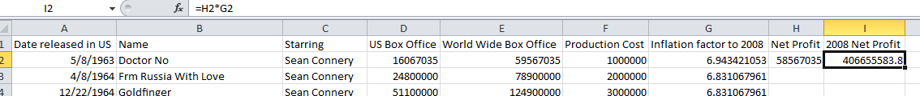

1. Create a pivot table on a new sheet which looks at the actors and determines their total **2008 net profit** for all the movies they starred in. This will be a one dimensional pivot table.
2. Sort this pivot table appropriately and you have the answer to our question at the top: Who was the most popular James Bond, at least by financial standards? Formatting the numbers wouldn’t be a bad idea either.
3. Let’s set up a pivot chart to visually document this.

3

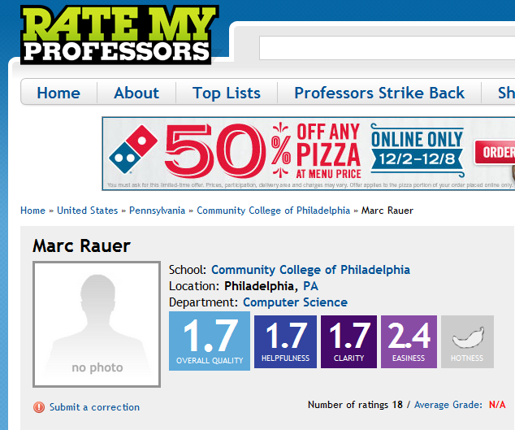44 pts. On the internet there are rating services that students can use to evaluate their instructors. Your instructor has brought down information for half the teaching staff at CCP which you can access at rating.xlsx where your files are.

Your instructor has not been highly rated as you can discern yourself but he's sure after this test that his ratings will skyrocket.

Let's take a minute or so to familiarize you with this excel spreadsheet. There are 682 line items. The columns read as follows: Instructors name, department, division, the avg student rating and the number of students rating each teacher. These are the figures on the internet. But your instructor has added through random number generation the position and two sets of tenure information (longevity) to each line item.

Here's what you are to do:

1. Apply the new table construct to this spreadsheet
2. Indicate that totals will apply and set an appropriate layout.
3. Sort the table showing the teachers with the highest number of Student responses at the top
4. Now, using filters and your total line, for the Business and Technology division, indicate the avg rating and the number of Student responses for that division. Remember: there are two math operators working here: average for ratings, and sum for student responses.

Avg rating____________________ Number of responses________________

1. Apply a further filter showing only those instructors in the Computer Sciences Department.
2. Now using your total line and a correct combination of the excel (aggregate) functions: Determine the number of faculty members (use the total line entry for the Name column for this), the minimum student rating to a faculty member, the total number of student evaluations and the average number of years on the faculty (tenure) for the Computer Sciences department.

Leave the spreadsheet like this as we move into pivot tables.

1. Create a pivot table showing average tenure by Division.
2. Sort this showing the highest first.
3. Handle the question of decimal
4. Create a pivot table chart that displays these values visually

Now, let's create a second pivot table off of our underlying data

1. Show a two dimensional pivot table showing the average of the average rating for the college divisions as rows and Teacher positions as column indicators.