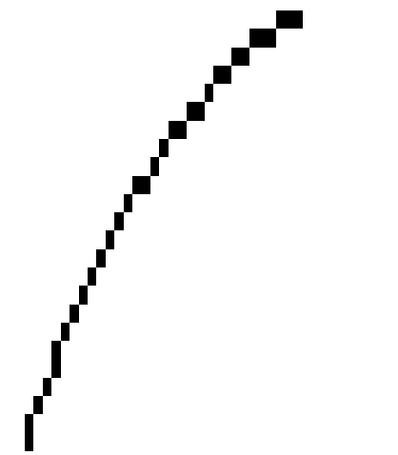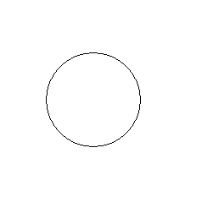In class last week, your instructor was talking about pixels and straight lines and how they create everything in windows. Your instructor sensed that some were unconvinced. So, let’s look at a circle (and by the way, everything here can be recreated on Paint, in fact that’s what was used here)

To the right is a circle (or possibly a very close approximation). In paint, you have the ability to magnify these things by eight times. Let’s see what this looks like when we magnified by 8 times. Obviously, we will quickly overwrite the paper, so here’s a segment of the circle

Notice that this is a set of limes, however small. Certain widths are added to the lines to set the pattern that makes the circle. The only reason you see a circle is because of an optical illusion: your eyes connect the dots, so to speak.

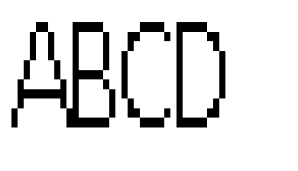This also applies to text. In the windows system, text is nothing more that the display of lines, circles and the like in a pattern that you see as letters.

Look at the text ABCD printed here. This is in Calibri 11 regular.To the right is what it is doing at 8 times the magnification

Notice the A. It’s not even a straight line. The aspect (height vs width) of this font is maintained by breaks in the slant of the A. Only the cross bar is a real line in it’s entirety. All these lines are created through instructions the Microsoft provides the operating system that exist in several files , one of which is Calibri.ttf. See if you can search for this file on your system?

What is ttf: True type font which is Microsoft’s way of saying it uses vectors, specific pixel placement and a 144 by 144 replica to create eachcharacter. Or a Wikipedia says: “The outlines of the characters (or [glyphs](http://en.wikipedia.org/wiki/Glyph)) in TrueType fonts are made of straight line segments and quadratic [Bézier curves](http://en.wikipedia.org/wiki/B%C3%A9zier_curve). These mathematically simpler curves are slightly more efficient to process than the cubic Bézier curves prevalent in the [PostScript](http://en.wikipedia.org/wiki/PostScript)-centered world of [graphic design](http://en.wikipedia.org/wiki/Graphic_design), and also used in Type 1 fonts. However, most shapes require more points to describe with quadratic curves than cubics.” Did this explanation help?

While we are looking at this enlargement of these characters, let’s discuss kerning which was mentioned last week. Do you see kerning in action? Well, consider this – a kerned font has variable widthed? Letters. Can you see that the B is not as wide as the C or the A. Notice how close the A is to the B. Notice also the cheating on the C as it is closer to the B because of the B’s shape. In a kerned font, the system has a file that ndicates the spacing that should occur between any two letters. In Microsoft word you can control this somewhat by kerning even further or lessening the effect. Keep in mind that the closer you kern, the harder it is to read.

While we are talking graphics here, your instructor should have included the following page in your syllabus that describes some of the fonts in existance. In this case, you can also the effect of leading..

|  |  |
| --- | --- |
| Times Roman 24Arial 24 Algerian 24 Arial narrow 24Bookman 24Century Gothic 24Courier 24Garamond 24Haettenschweiler 24Impact 24 Kaiti 24 Lucida 24Tahoma 24Verdana 24 | Times Roman 24Arial 24 Algerian 24 Arial narrow 24Bookman 24Century Gothic 24Courier 24Garamond 24Haettenschweiler 24Impact 24Lucida 24 Kaiti 24 Tahoma 24Verdana 24 |
| *TIMES ROMAN* | | |

Your instructor may discuss some of these, but look at Haettenschweiler. This is a typical German font. Why? Fonts a created by the graphic artist to express a specific feel and look. Can you explain the feel and look of impact or Arial.

Your instructor also mentioned the question of 3d imagery on a 2D screen. This is done by shading. To the right is a rectangle. Now, let’s take that rectangle and create a shadow to the right and below which you can see below right.

notice how it seems to come out to you. This is the perfect command button. Now let’s reverse this below left.

You should see a slight indent and it would be more evident if your instructor had any art talent at all.

**Font Definitions**

|  |  |
| --- | --- |
| **Font Style** | Cartographer’s concept of how text should look |
| **Font** | Variation of style depending on weight (below), slant |
| **Weight** | Amount of ink – pixels – used in creation of character |
| **serif** | Block at end of character if fontstyle supports such. If not supported, font (style) is described as sans serif |
| **Bold** | Font providing characters with extra weight |
| **Italics** | Font is pivoted 30% (normally) from the bottom |
| **Point** | Generally 1/32 (or is it 1/64) of an inch. In the end it is the height of a period |
| **Aspect** | Ratio of height of character to its width |
| **Lower case** | Small letters |
| **Upper case** | Large letters |
| **Ascender** | Part of character above normal lower case character. Example, any cap or small b |
| **Descender** | Part of character below normal lower case character. Example, j or y |
| **Fixed font** | Size (height and width) of each character is the same. Most famous fixed fonts – courier and Huelvetica |
| **Proportional Font** | Width of character varies depending on which character is next |
| **Font Table** | Table indicating space between any two characters |
| **Kerning** | Process in a proportional font of using the font table to set characters  These three paragraphs should indicate to you the difference between fixed, proportion and condensed fonts  These three paragraphs should indicate to you the difference between fixed, proportion and condensed fonts  These three paragraphs should indicate to you the difference between fixed, proportion and condensed fonts |
| **Leading** | Similar to kerning except done with lines. Determination of where to place the next line  These two paragraphs should indicate the question of leading to you. In the first paragraph regular leading is in effect which polls each a line, determines the size of the largest descender and assumes a certain amount of space to skip prior to the next line. That line is set by the highest ascender. The second paragraph compresses this spacing  These two paragraphs should indicate the question of leading to you. In the first paragraph regular leading is in effect which polls each a line, determines the size of the largest descender and assumes a certain amount of space to skip prior to the next line. That line is set by the highest ascender. The second paragraph compresses this spacing |

Let’s use some of the API concepts to create our CIS103 mascot to the right. This is a crude, rather disrespectful representation of the 2 felines who are determined to destroy my furniture one piece at a time.

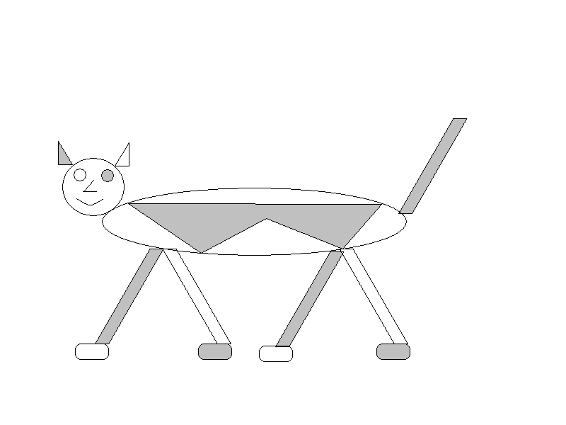

Now, try to do this given our discussions.

Torso is an ellipse

Head is a circle. Use cut and paste (select tool) to move these together.

Create one object and use copy and paste to create the feet and tail.

Use one rounded rectangle to create the paws.

An Ear is a polygon. Use copy to create the second.

One eye is a circle. Clone it to create the second.

Smile is a curve

Nose is two straight lines

Body art on torso is a polygon

Use paint can to create fills

**Try your hand at cat art**

First, let’s start with the head. A circle will do. Create a circle that is big enough to hold the cat’s features, but small not o dwarf the body.

To the right is an example.

Now the body. An ellipse will do, but remember we have cut, copy and paste capabilities. Create the body away from the head. The left would be an example of the ellipse. Click attributes and set **draw opaque** off. Now, lasso the ellipse and move it to the body as indicated below.

Let’s do the feet and tail. Create a rectangle as indicated to the right

Lasso it and skew it 30% or so as shown to the far right. Lasso it

Again and paste it. You should now have this image of the rectangle

at the top. Lasso it and move it to become a foot as indicated below

Hit paste again and set the back “forward foot”. This will work as a tail also. See if you can place that. At the end you have the following

Now, take the original foot and rotate it 180 degrees. Do lassoing and copy and paste to create the other foot



How about the paws? A rounded rectangle will do as indicated to the right.

Lasso this and copy and paste three times while setting the paws



Window controls – min,max and end

Class exercise:

Look for the **perfectobject.doc** file on **My Documents.** What type of file is this. _________________ How can you tell.

What are the two ways that this file could be loaded______________________ __________________________________________

What ribbons are visible___________________________________________________

At the moment, how many paragraphs are there in the document _________________

Why do you think that some people call the properties such as author and edit by meta data_________________________________________

How many words ____________________ Characters____________________

What is the **date recorded** value. _______________________

What is the size of the file as far as the operating system is concerned_______________

Considering the characters indicated in a previous question ,why is the file so much bigger to the operating system that to word_________________________________

What are the present margins: Top_________ Left___________ right______________ bottom ______________

What can be said about these margins in terms of how we read documents in our society______________________________________________________

Is this document is portrait or landscape?___________ Which is better for this document?___________

As you look at the document, you are in a Word view. What views are available in Word______________________

Would we see these margins if we were in normal view. Why or why not _____________________________________

Let’s look at paragraphs. We indicated the number above. Your instructor has discussed the definition in word processing. It is true that your English teacher would not indicate the number of paragraphs that the system does. Why would he be incorrect as far as your system is concerned _______________________________________________

Speaking of paragraphs, paragraphs can be modified by the ruler. Indicate the type of changes your ruler can do _____________________________________________

Paragraphs are indicated by a special character. You can see this using hide and show. Prove this by setting the Hide of Hide Show.

Besides enter keys, what other characters are specifically indicated by hide show_____________

What special keys can be used to navigate this document__________________________

How does the scroll bar aid navigation____________________________________

Navigation can also be applied using the goto command. Let’s enter this and discuss it.

Using goto, what does a + or – do when specifically indicated as an entry ______________________________________________

What does zoom do. ________________What is the easy way to control it?_______________________

What font is the text in___________ Points___________. What can you say about this Font_______________________________

We want to change this font to calibri 16. To do this we need to select the entire document. How do you select all the text______________________________

As a general rule, how much bigger will Calibri 16 be from the present font. ________________________ What other factor comes into play.

Can you come up with a quick way of increasing and decreasing the point size for the 3rd paragraph______________________________________________________

Now, try italicizing this 3rd paragraph. What can be said about this?__________________________________________________________

Assuming you like the way the 3rd paragraph look, how could you quickly make the other paragraphs look the same _________________________________

Your instructor should have shown you two ways to do the above – format painter and style. What can you say about each?______________________________________

What is a header?_______________________ What is a footer?_______________

How do we access headers and footers using the ribbon?___________ How about the mouse?________________________________

Cut the first paragraph How the Grinch stole perfect objects and paste it to make this the header

How do we save a word document?___________________________________

What are the possible extensions that can be used?__________________ How does this affect compatibility?___________________________

Save this file from the Q drive to your flash memory device. This is the original and you can use send to.

Save this file to your flash memory as you have changed it in Microsoft Word. When you get home, try these exercises at home.