


Welcome to MyITLab for Office 2010!
MyITLab for Office 2010 is a dynamic, interactive eLearning program for your Office 2010 course. Your instructor has requested that you have access to this online program.

To access your MyITLab for Office 2010 online course, you need to first register for MyITLab and then log in and enroll in your course. Whenever you want to use MyITLab after that, you just log in at www.MyITLab.com.

Register for MyITLab for Office 2010

To register, you will need a student access code and a course ID (provided by your instructor). If you purchased a new textbook, it should have come with a Student Access Kit that contains a code you can use to register. If you do not have a Student Access Kit, you can purchase access online with a major credit card.

STEP 1: Go to www.myitlab.com

STEP 2: You will then be asked to select the version of MyITLab you are using for the course.
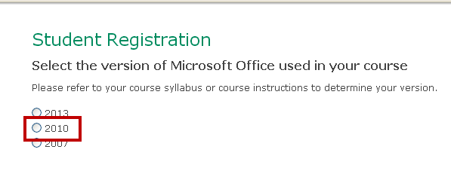
STEP 3: You will now select whether you have an access code or if you need to buy an access code.
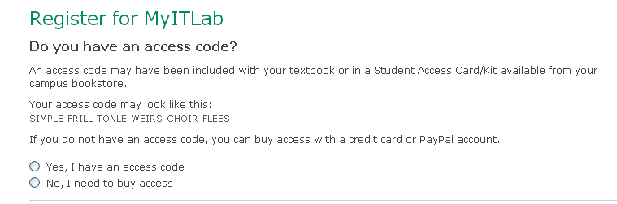
STEP 4: If you have an access code, you will jump to step 7 and complete the registration process.

STEP 5: If you selected to buy access, you will now select the textbook(s) you are using in your course and then move to the License Agreement page to complete the registration process.

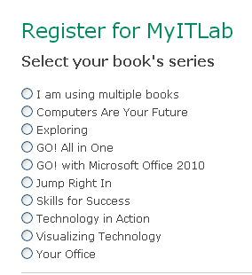
STEP 6: Agree to the License Agreement and terms by clicking I Accept.
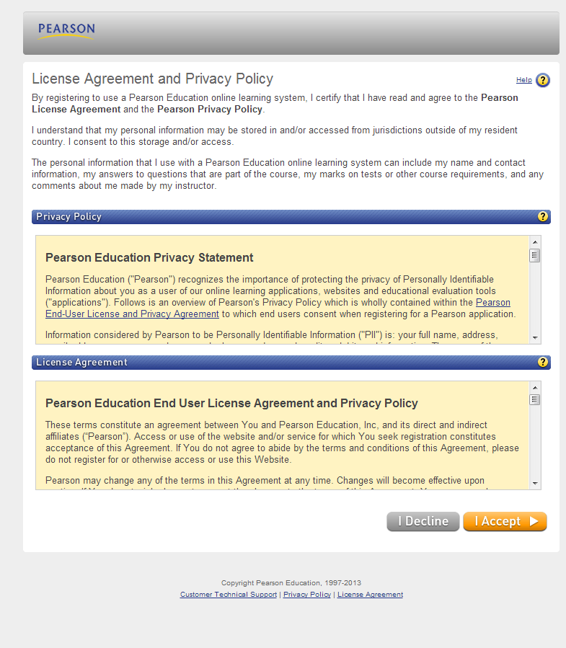
STEP 7: On the Access Information page, you will be asked if you have a Pearson Education account. If Yes, enter the existing login name and password.

STEP 8: If you do not have an account, click the No option, and enter your desired login name and password. Re-type your password.

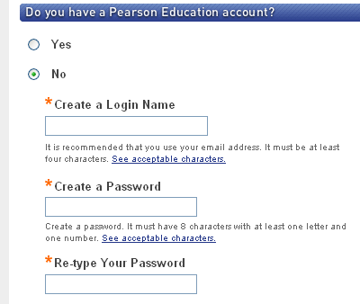

STEP 9: Enter your Access Code from the MyITLab Student Access Kit.

STEP 10: On the Account Information page, enter your first and last name and email.

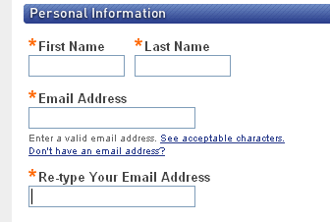

STEP 11: In the School Location section, select your country and enter your school’s ZIP or postal code. Select your school from the list.

STEP 12: Select a Security Question and enter the answer. Click Next.

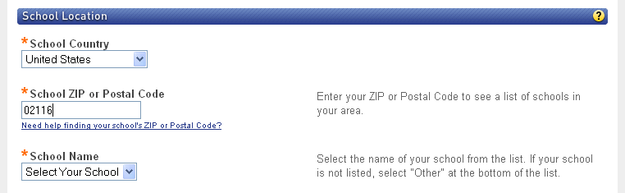

STEP 13: A Confirmation and Summary page displays, indicating your registration is successful! This information will also be emailed to you.

STEP 14: Click the “Log in Now” button.

STEP 15: On the My Courses and Testbanks page, click Enroll in a Course and type the Course ID provided to you by your instructor—it will be similar to this: CRSABQW-123456.

STEP 16: On the Confirm Course page verify the course and instructor are correct. Click Submit, and then Enter Course Now.

To log into MyITLab for Office 2010

STEP 1: Go to www.MyITLab.com and click Sign In.

STEP 2: When you click Sign In select 2010.

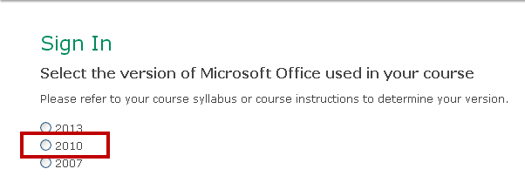.

STEP 3: Login with your Username and Password.
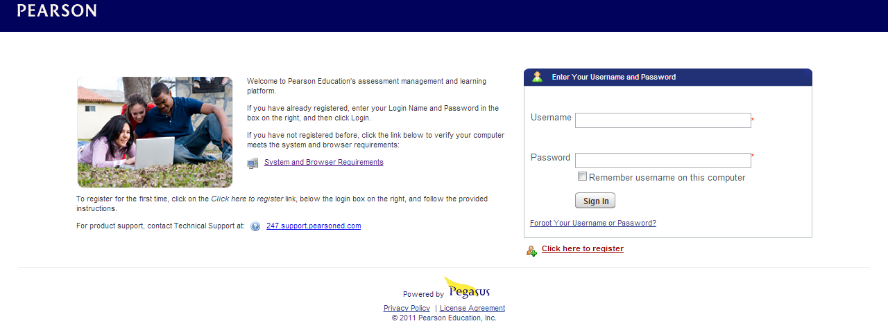
Getting Your Home Computer Set Up For MyITLab for Office 2010
Please follow the steps below to ensure your home computer is ready to run MyITLab for Office 2010.
MAC USERS: The resources below are intended to be used by Windows/PC users only, not by Mac users. Mac users should visit www.myitlab.com to obtain access to our Mac Compatibility Solution.
STEP 1: Navigate to www.myitlab.com. Click the Support tab at the top and then the Home Computer Set-Up link.
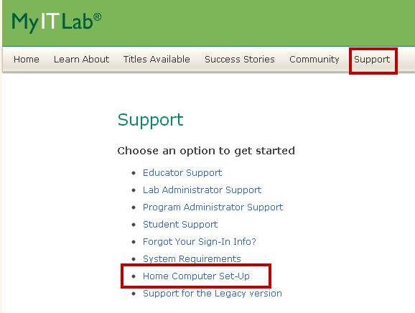
STEP 2: Select MyITLab for Office 2010/2007.
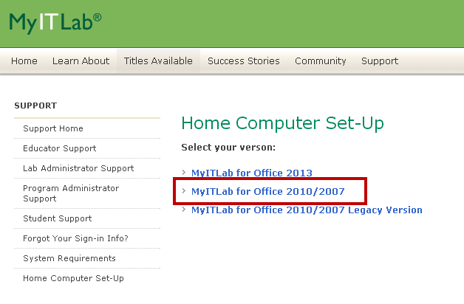

STEP 3: From this page, click the blue One-Step Installer & Launch Tool box.


STEP 3: When prompted, click ‘Run’ to initiate the process (do not select ‘Save’).
STEP 4: Follow the prompts on the screen, and complete each of the wizards to finish installing all necessary elements.
STEP 5: Once complete, close ALL internet browser windows that you might have open.
STEP 6: Locate the new Launch MyITLab icon now on your desktop. Double-click the icon and begin logging into MyITLab.

STEP 7: EVERYTIME you access MyITLab on your home computer, close ALL internet browser windows and then click the Launch MyITLab icon on your desktop. (You do not need to access this One-Step Installer & Launch Tool download page anymore. Just use the icon on your desktop.) Ensuring a successful experience with MyITLab, the Launch MyITLab icon will perform the following actions:
  - Empty your Temporary Internet Files.
  - Set your screen resolution to the optimal setting for MyITLab (1024x768) and reset your screen resolution when Internet Explorer is closed.
  - Launch Internet Explorer and take you to the MyITLab website.

